Turabian format - Title page
All text on the title page should be center-aligned and double-spaced, and written in the same font as the rest of your text. The title should appear about ⅓ of the way down the page, in headline capitalization and in bold.
If you have a subtitle, the main title ends with a colon and the subtitle appears on the following line, also in bold and the same size as the main title.
About ⅔ of the way down the page, add any information your instructor requests you to include—your name, student code, the course name and code, the date, etc. Each new piece of information appears on a new line.
The title page should not have a page number, but should be included in the page count—in other words, the page numbering starts on page 2.
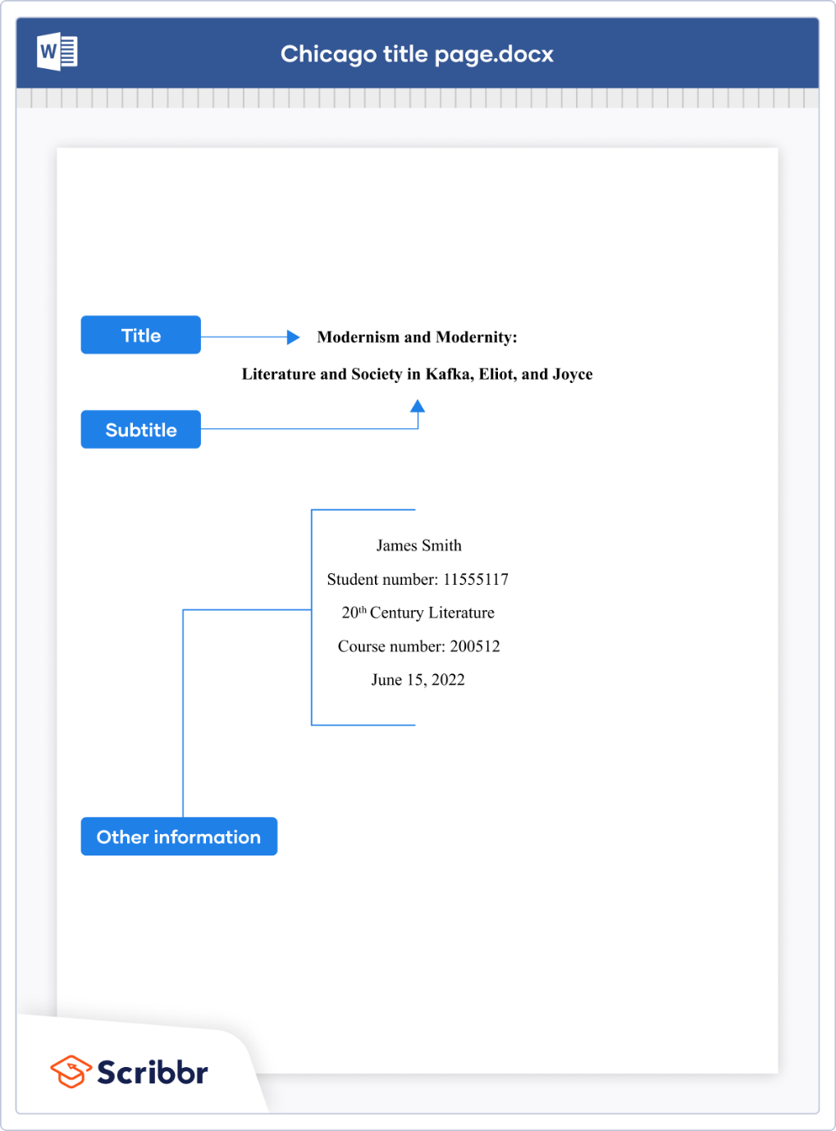

Headings
Headings should use headline capitalization:
- Summary of results
- Summary of Results
If you use different levels of heading (e.g., chapters, sections, subheadings), make sure your presentation makes clear which type of heading each one is.
All headings of one level should be presented the same way, and higher-level headings should stand out more from the text. For example, you might use a larger font for chapter headings, bold for section headings, and italics for subheadings:
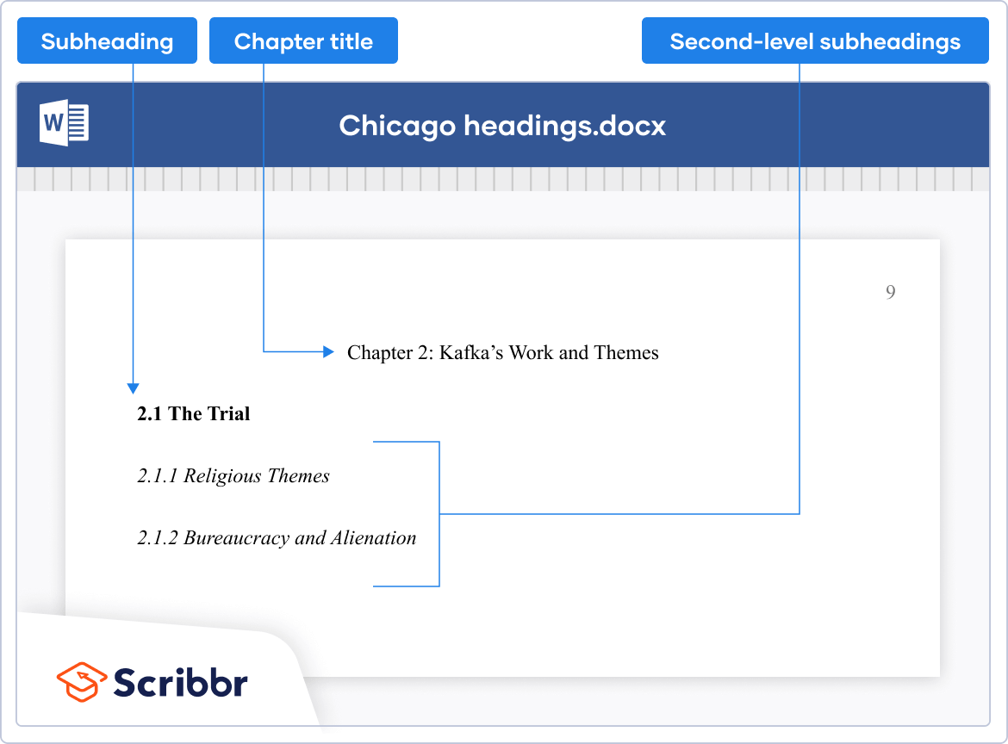

Block quotes
Prose quotations of five or more lines (or more than 100 words), as well as poetry quotations of two or more lines, are presented as block quotes.
Block quotes do not use quotation marks. Instead, a blank line separates them from the surrounding text on both sides and they are indented by an additional ½ inch. Unlike the rest of the text, they are not double-spaced.

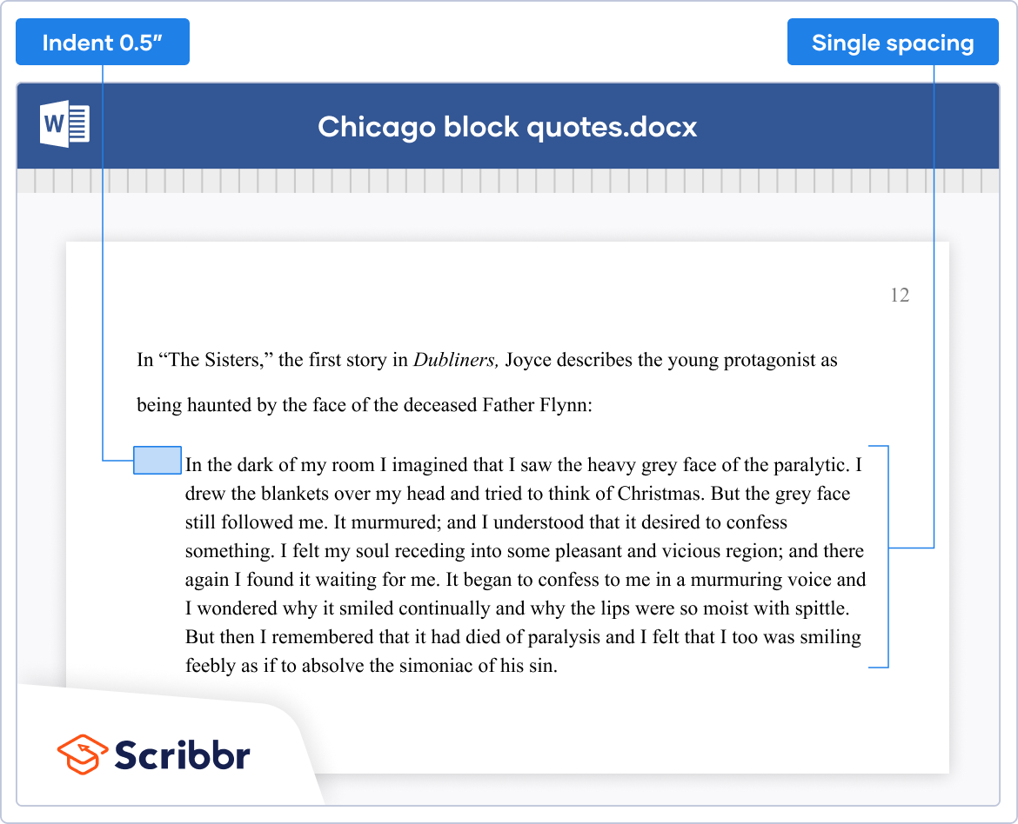

In-text citations and notes
Chicago provides guidelines for not one but two citation styles: author-date and notes and bibliography.
In author-date style, citations are placed directly in the text in parentheses. In this style, you have some flexibility about how exactly to integrate the citation:
Davis (2016) argues that the theory is “sound.” Other researchers, however, have contradicted this assessment (Lee et al. 2017; Johnson 2018).
In notes and bibliography style, citations appear in Chicago footnotes or endnotes (the format is identical either way), and the reader is referred to them by superscript numbers in the text.
Footnote and endnote numbers appear at the end of the relevant clause or sentence, after any punctuation except a dash.
Endnotes appear on their own page just before the bibliography; footnotes appear at the bottom of each page. Footnotes should be separated from the text by a short rule and be presented in the same font size as the main text, or smaller. Word’s footnote function automatically creates footnotes like this:
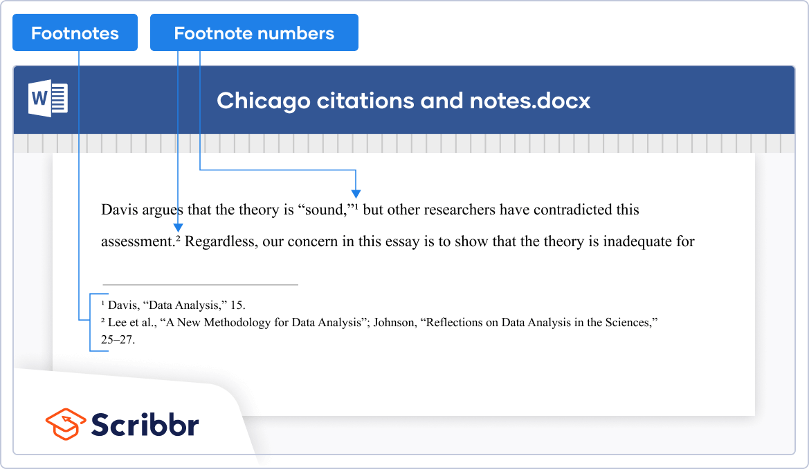
Bibliography or reference list
At the end of your paper, you’ll likely include a bibliography (for notes and bibliography style) or a reference list (for author-date).
Bibliographies and reference lists are not double-spaced, but leave a blank line between entries.
If an entry extends onto a second line, a ½ inch indent should be applied to all but the first line of the entry.

If you have to create a Chicago style annotated bibliography, follow the same format as a normal bibliography, but indent and double-space the annotations under each source reference.

