Tips for Formatting MLA Papers Using Microsoft Word Online
Formatting MLA papers using Microsoft Word can be challenging if you are not used to using the software. Luckily, Microsoft has several built-in shortcuts and tools that can help to simplify formatting your paper to MLA standards. Use the following tips to assist you in formatting your MLA paper.

Margins
MLA (9th edition) requires that papers have a one-inch margin on all sides of each page. To set your margins so that they adhere to MLA guidelines, use the following steps:

- Press the “Ctrl” and “A” keys on your keyboard at the same time to select the entire paper (even if you do not have anything written yet, doing so will ensure that the margin settings apply to the entire paper, not just the first page).
- Click on the “Page Layout” tab of the Word menu.
- Click on the “Margins” dropdown menu button.
- Select the “Normal” option showing one-inch margins on each side of the page.
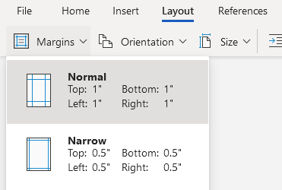

Page Numbers
MLA requires that papers have page numbers in the upper right-hand corner of every page. To insert page numbers that will automatically carry over onto every new page of your document, use the following steps:

- Click on the “Insert” tab of the Word menu.
- Click on the “Page Number” dropdown menu button.
- Select the third option on the top row, with the number in the upper-right corner.
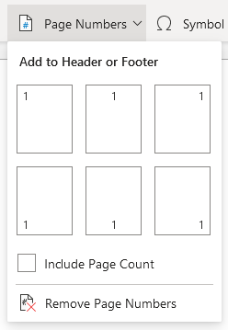
- Type your last name followed by a space before the page number.
- Press the “Ctrl” and “A” keys on your keyboard at the same time to select all text in the header and change the font to Times New Roman 12pt so that it matches the font of the rest of your paper (ALL text in your paper should be in Times New Roman 12pt).

Heading
Although writing a standard MLA heading seems simple enough, many have trouble remembering the correct order of the heading’s contents. Many also tend to place the heading incorrectly in the header of their paper. The heading should be placed at the top of the main page of the paper, starting on the first line, and should appear as follows:

The standard MLA heading should include your first and last name, your professor’s name, the class that the paper is being written for, and the paper’s due date. To remember this order, use the following mnemonic device:
No (“N” for name)
Professor (“P” for professor’s name)
Can (“C” for class name)
Dance (“D” for date)

Some professors require that you include other information (e.g. the paper’s word count) in your heading. This information should be included on the line directly following the header (underneath the date). If your professor asks for something other than the standard MLA header, defer to your professor’s instructions.

Spacing

According to MLA, your entire paper should be double spaced. Use the following steps to double space your paper:

- Press the “Ctrl” and “A” keys on your keyboard at the same time to select the entire paper (even if you don’t have anything written yet, doing so will ensure that the double spacing applies to the entire paper, not just the first line).
- Click on the three dots (...) to the far right of the “Home” section (see image below).
- From the drop-down menu that appears, choose “Paragraph Options.”
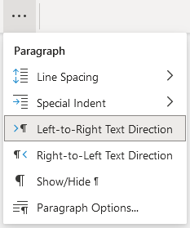
- Once in paragraph window, select “Double” from the “Line Spacing” drop-down menu.
- Make sure that both the “Before” and “After” fields say “0 pt” to remove/prevent any extra spacing.
- Before closing the paragraph window, make sure that it resembles the example below.

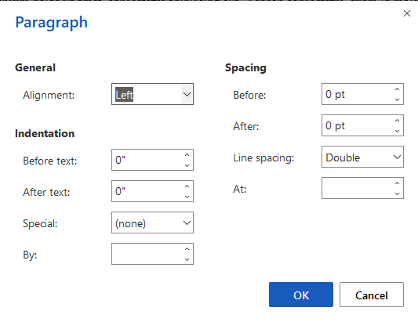

Titles
All MLA papers should include an original title (i.e. not the title of the assignment, something that tells your reader what the paper will be about). After typing your heading, hit the “Enter” key on your keyboard once and then type out your paper’s title. Capitalize the first and last words of the title and all other words except for articles (a, an, and the), prepositions (in, of, to, for, etc.), and coordinating conjunctions or FANBOYS (for, and, nor, but, or, yet, and so) unless those exception words appear as the first or last word of the title or the first word in a subtitle following a colon. These capitalization rules also apply to the titles of outside sources (articles, books, etc.) on your Works Cited page.

According to MLA format guidelines, your title should also be centered. To center your title, use the following steps:

- Select your entire title.
- Click on the Text Alignment button () under Word’s “Home” section.
- From the drop-down menu that appears, choose the Align Center button.
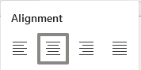

Use these steps and guidelines to format the title of your Works Cited page as well (be careful to use the words “Works Cited” for this page’s title, not “Bibliography,” “References,” etc.).

Paragraph Indents
According to MLA, all paragraphs should be indented one half (.5) of an inch. To set Word to automatically indent your paragraphs each time you hit the “enter” key on your keyboard, use the following steps:

- If you are unable to see a ruler between the bottom of the Word menu and the top of your page, perform these steps before moving on to step two:
  - Click on the “View” tab of the Word menu.
  - Check the box beside the “Ruler” option of the “Show” section of the menu.

  - Now the ruler should be visible as shown below.

- Now that you can see the ruler, you can add your indent. Hit the “Enter” key to move onto the line directly below your title (there should be no extra lines between your title and the first line of your paper’s first paragraph), click on the Text Alignment button under Word’s “Home” section, and click on the Align Left button () to return your cursor to the left-side margin of your page.
- Click and drag the top triangle on the ruler’s left-hand margin so that it sits on the line halfway between your left-hand margin and the “1” on the ruler. Your ruler should end up looking like the example below.

Now Word will automatically indent half an inch every time you hit the “Enter” key to move on to a new paragraph. If you need to remove this automatic indent for any reason, all you have to do is place your cursor before the indent and press the “Backspace” key to delete it.

Block Quotations
MLA states that when a quotation is longer than three lines of typed text, it should be formatted as a block quote. Block quotes are set apart from the text of your paragraph and indented half an inch from the left-hand margin. To correctly format a block quote, use the following steps:

- First, introduce your lengthy quote with a complete sentence and a colon (:).
- Type out your quoted material without any quotation marks (the block format will take the place of quotation marks to show that the material is from another source).
- Be sure to include a citation following the quote. Unlike with shorter quotations, the period ending the quotation sentence will fall directly following the quote with the citation falling outside the sentence altogether.
- Now, type another sentence addressing your quote (this step is important both for your paper’s effectiveness and for the formatting of your block quotation).
- Place your cursor before the quote and press the “Enter” key as if you are starting a new paragraph.
- Place your cursor before the sentence following your quote and press the “Enter” key as if you are starting a new paragraph. If you have automatic indents set, press the “Backspace” key once to remove the indent so that the remaining text of your paragraph after the quote will start at the margin, eliminating any confusion for your reader.
- Select the entire quote and citation.
- Press the “tab” key once to indent the entire quotation half an inch from the margin.
- Your block quote should end up looking like the example on the next page.

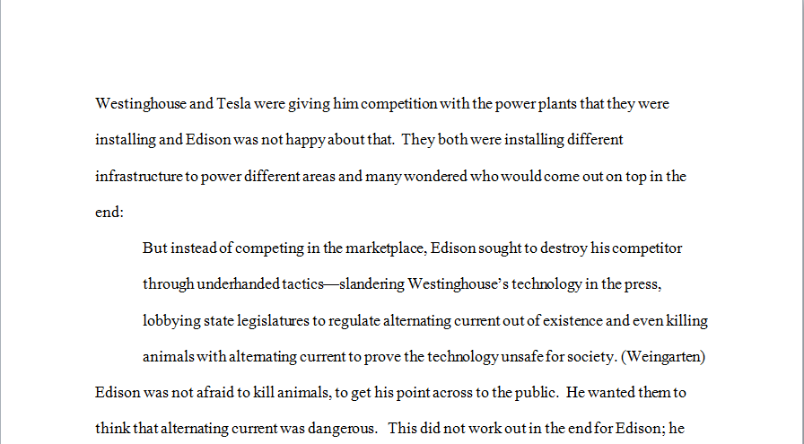

Try not to use too many block quotes in your paper. Your own words should make up the bulk of your paper’s text.

Hanging Indent
Each citation on your Works Cited page should be formatted with a hanging indent. A hanging indent occurs when the first line of the citation begins on the left-hand margin and the second line of the citation is indented half an inch from that margin. To format your Works Cited page using hanging indent, use the following steps:

- Place your cursor at the very end of your paper and press the “Ctrl” and “Enter” keys at the same time to create a page break.
- If Word automatically indents on the new page, press the “Backspace” key once to delete the indent.
- Click on the Text Alignment button under Word’s “Home” menu (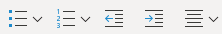), then choose the “Align Center” button from the drop-down menu that appears ().
- Type “Works Cited” (without quotation marks) as your title.
- Press the “Enter” key, click the Text Alignment button under Word’s “Home” menu, and click on the Align Left button () to return your cursor to the left-side margin of your page.
- Type out all of your Works Cited page citations, pressing the “Enter” key after each citation.
- Select all of your citations, but do not select page’s title.
- Right click on the highlighted text and choose “Paragraph Options” from the drop-down menu that appears.
- In the window that appears, click the drop-down menu next to the word “Special:” and choose “Hanging,” and make sure that the box below that (next to the word “By:”) says 0.5”, as in the image below.
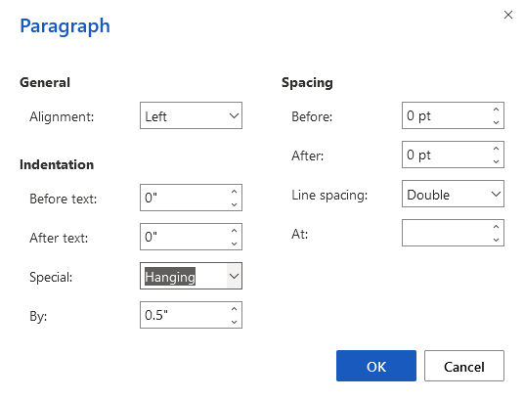
- Your citation(s) should end up looking like the example below.

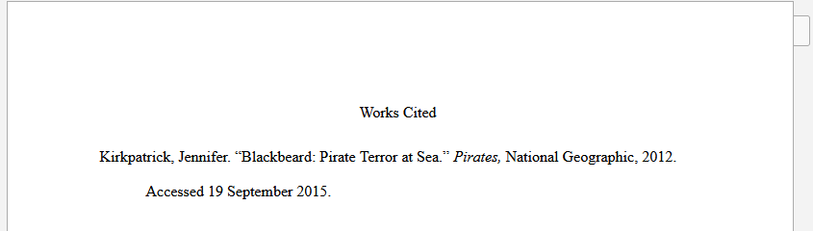

The citations on your Works Cited page and your in-text citations should follow MLA guidelines. For more information regarding MLA citations, see the Pensacola State College Writing Lab’s MLA handout or reference the Purdue OWL MLA Formatting and Style Guide.

