Argumentative Paper: PSC Writing Lab planning worksheet
Step 1: Choose a Debatable Issue
Choose an issue that reasonable people could disagree on. Do not try to write an argument paper about an established fact (smoking increases one’s chances of developing lung cancer). Stay away from overused topics. What issue are you passionate about? What issue impacts YOU and your life in a positive or negative way? ________________________________________________________
Step 2: Choose a Side
Even though you may understand and even agree with elements of both sides of the argument, for this assignment you MUST choose to argue from one side or the other. Which side are you most comfortable writing about? __________________________________________________________
Step 3: Develop a Basic Thesis Statement
For this type of paper, a basic thesis should simply tell readers the main argument you plan to defend and explain in the paper. We’ll elaborate and create a more advanced thesis later on—this is just to get us started. If you’re having trouble choosing the right words to express that argument, try using this template: [Debatable Issue] should/should not [Explain Your Side of Argument].
EXAMPLE: Unhealthy vending machine snacks should not be sold in K-12 school cafeterias.
EXAMPLE: Recycling containers should be mandatory in all K-12 school classrooms.
Write your basic thesis statement here: __________________________________________________________________________________________________________________________________________________________________________
Step 4: Develop Three Main Reasons Others Should Agree with You
Before you start researching this topic or thinking too deeply about the specific parts of it, you need to figure out the main reasons why you feel others should agree with your side of this argument. Fill in the blanks below, making sure that you have three different reasons that do not overlap. Others should agree with me because…
Reason 1: ____________________________________________________________________________
Reason 2: ____________________________________________________________________________
Reason 3: ____________________________________________________________________________

Step 5: Create a Research Plan
Once you’ve decided on (at least) 3 main reasons why others should agree with you, it’s time to start thinking about what kinds of evidence you’ll need to support those points. For now, just remember…
Use your H-E-A-D!
Historical Records—information about the past or proven track records similar to your point
Experts—people and publications whose opinions and ideas about this topic can be trusted
Anecdotal Examples—everyday people who can describe their experiences with this topic
Data—facts, data, or statistics that would help support your point

Reason 1 | Reason 2 | Reason 3
H: | H: | H:
E: | E: | E:
A: | A: | A:
D: | D: | D:

Step 6: Plan out the Structure of your Rough Draft
- Introduction: provide an attention-grabbing fact or quote that helps introduce your topic.
  - When did we first start debating this topic? What started it? Why is it still important?
  - What are the two sides of this debate? Why do people disagree?
  - Thesis_____________________________________________________________
- Reason 1 _____________________________________________________________
- HEAD support: ____________________________________________________
- HEAD support: ____________________________________________________
- Reason 2 _______________________________________________________
- HEAD support: ____________________________________________________
- HEAD support: ____________________________________________________
- Reason 3 ___________________________________________________________
- HEAD support: ____________________________________________________
- HEAD support: ____________________________________________________
- Naysayer/Counter Argument: acknowledge that others may disagree. (example on back)
  - What’s one reason why others might disagree with you? Explain.
  - What’s another reason why others might disagree with you? Explain.
  - Make it clear that while you understand their perspective, you still disagree because…
- Conclusion: re-state your thesis (in slightly different words).
- Review each of your main points
- Why should we care? How can we get involved to support your cause?
- Add an MLA Works Cited page—cite ALL of the sources you quoted or paraphrased!
How to write an effective naysayer/counter argument paragraph
Imagine the people who might be most likely to disagree with you on this issue, and think about why they might feel that way. You should acknowledge their concerns or areas of disagreement in your paragraph. Be sure to use a reasonable, compassionate tone. Before you end the paragraph, make it clear that, despite their objections, you still believe your views are correct—and explain why.
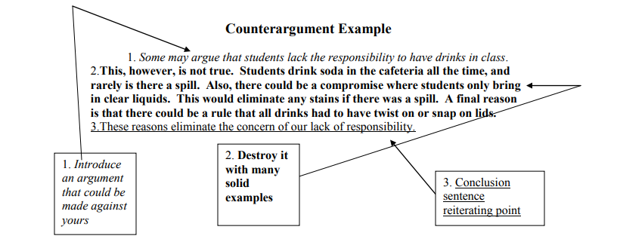
Templates for Disagreeing (taken from They Say, I Say by Graff & Birkenstein)
- I think X is mistaken because she overlooks __________ .
- X's claim that __________ rests upon the questionable assumption that ________ .
- I disagree with X's view that ________ because, as recent research has shown ________ .
- X contradicts herself/can't have it both ways. On the one hand, she argues ________. But on the other hand, she also says __________ .
- By focusing on _________ , X overlooks the deeper problem of ____________ .
- X claims __________ , but we don't need him to tell us that. Anyone familiar with ________ has long known that _____________ .

