Coordinating Conjunctions
A coordinating conjunction is the part of a compound sentence where two independent clauses are joined together.Independent clauses are complete sentences that make sense on their own. Coordinating conjunctions imply a specific relationship between complete sentences. You can remember the coordinating conjunctions with the acronym “FANBOYS.”
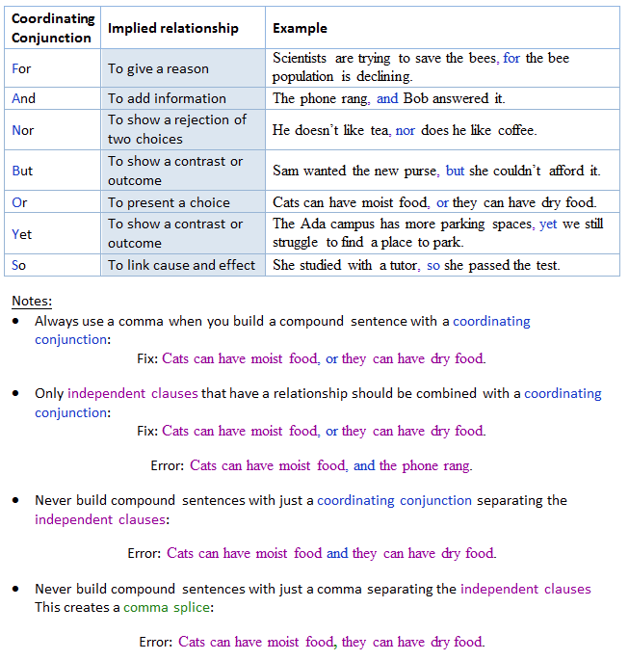
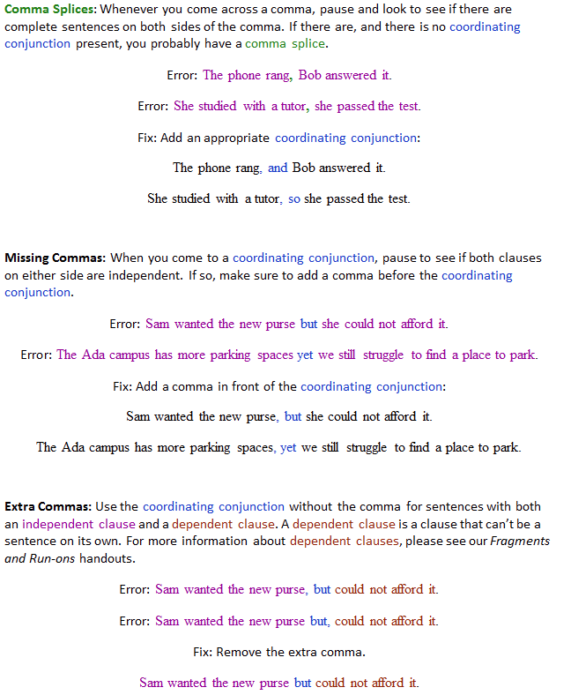
Note: If you would like practice with identifying and correcting these errors, please see our Coordinating Conjunctions Worksheet!
For more information, contact the Writing Center.

