**1. Highlight all of your citations.**

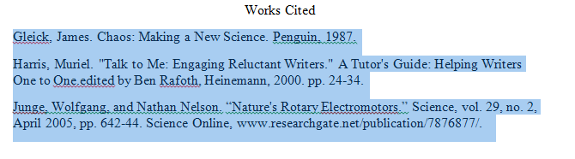

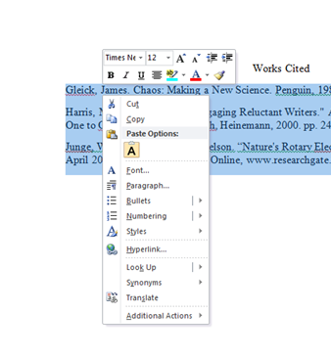

**4. Click the drop-down arrow next to Special and select Hanging. Make sure the value next to it is set to 0.5”.**

**3. Select Paragraph.**

**2. Hover the cursor over the highlighted text and right-click directly on it.**

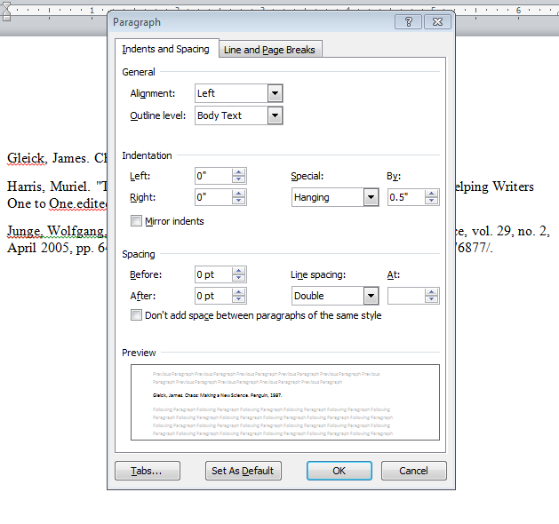

**TURN OVER** **to see what it will look like when you are finished!** 🡪

**7. Click OK.**

**6. Click the drop-down arrow beneath Line Spacing and select Double.**

**5. Make sure all of these values are set to 0**.

**MLA**

**Be sure that sources are arranged in alphabetical order.**

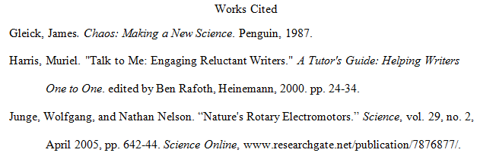

**APA**

**Be sure that sources are arranged in alphabetical order.**

