Tips for Formatting Turabian Papers Using Microsoft Word 2013
Formatting Turabian papers using Microsoft Word 2013 (the current edition available in the PSC Writing Lab) can be challenging if you are not used to using the software. Luckily, Microsoft has several built-in shortcuts and tools that can help to simplify formatting your paper to Turabian standards. Most professors who require the use of Turabian format will provide their own instructions on how to format your paper. Always defer to your professor’s instructions when formatting your paper. Use the following tips to assist you in formatting your Turabian paper.

Margins
Turabian (8th edition) requires that papers have a one-inch margin on all sides of each page. To set your margins so that they adhere to Turabian guidelines, use the following steps:

- Press the “Ctrl” and “A” keys on your keyboard at the same time to select the entire paper (even if you do not have anything written yet, doing so will ensure that the margin settings apply to the entire paper, not just the first page).
- Click on the “Page Layout” tab of the Word menu.
- Click on the “Margins” dropdown menu button.
- Select the “Normal” option showing one-inch margins on each side of the page.

Spacing

According to Turabian, your entire paper should be double spaced except for block quotations. Use the following steps to double space your paper:

- Press the “Ctrl” and “A” keys on your keyboard at the same time to select the entire paper (even if you don’t have anything written yet, doing so will ensure that the double spacing applies to the entire paper, not just the first line).
- Click on the expand button () in lower right-hand corner of the “Paragraph” section of Word’s “Home” menu to open paragraph window (see image below for more detail).
- Once in paragraph window, select “Double” from the “Line Spacing” drop-down menu.
- Make sure that both the “Before” and “After” fields say “0 pt” to remove/prevent any extra spacing.
- Check the box next to “Don’t add space between paragraphs of the same style.”
- Before closing the paragraph window, make sure that it resembles the example below.

Title Page
Turabian requires that papers begin with a title page. Your Turabian title page should at minimum include the title of your paper, your first and last name, your course/class information, and your paper’s due date. Your title page information should be centered, double spaced, and typed in 12-point Times New Roman (ALL text in your paper should be double spaced and in Times New Roman 12pt). Follow the following steps to format your title page correctly:

- Start on the first line of your paper’s first page.
- Click on the center button () in the “Paragraph” section of Word’s “Home” menu.
- Click on the bold button () in the “Font” section of Word’s “Home” menu.
- Press the “Enter” key on your keyboard five or six times so that your cursor is approximately one third of the way down the page.
- Type your paper’s title (e.g., Successful Plundering: The Blackbeard Method). If your paper has a subtitle (“The Blackbeard Method” in the sample above), press the “Enter” key on your keyboard and place it on the line directly underneath your main title.
- Click on the bold button again to turn off bold.
- Press the “Enter” key on your keyboard five or six times so that your cursor is approximately two thirds of the way down the page.
- Type your first and last name.
- Press the “Enter” key once.
- Type your class name.
- Press the “Enter” key once.
- Type the paper’s due date.
- To move on to the next page of your paper, press the “Ctrl” and “Enter” keys at the same time to insert a page break.

Your title page should look similar to the sample below:

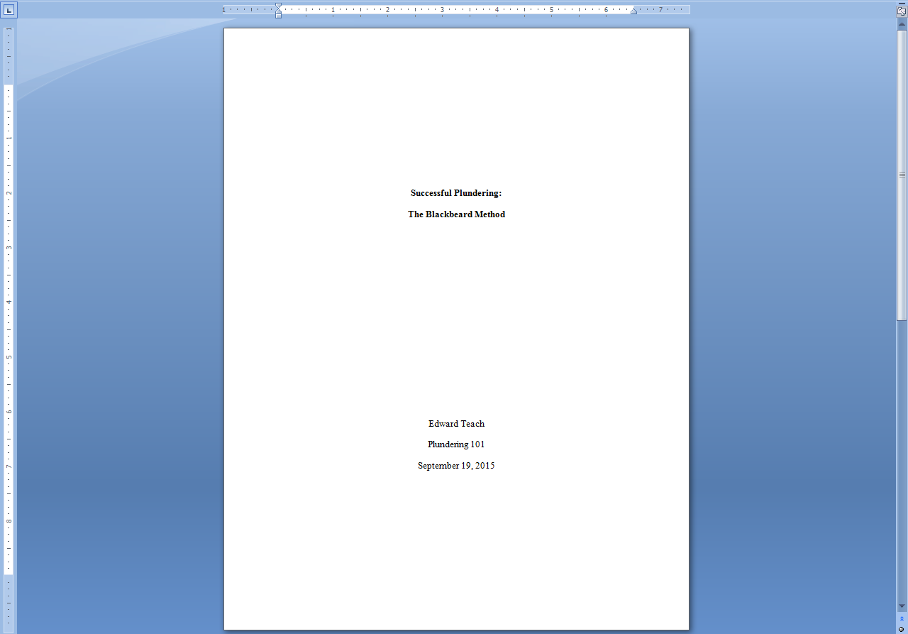

Some professors may require that you include other information (e.g. your institution’s name, your professor’s name, etc.) on your title page or that you format your title page differently (e.g. putting the title in ALL CAPS). If your professor asks for any more information or for alternate formatting, defer to your professor’s instructions and include all information they may require.

Page Numbers
Turabian requires that papers have page numbers in the upper right-hand corner of every page. To insert page numbers that will automatically carry over onto every new page of your document, use the following steps:

- Click on the “Insert” tab of the Word menu.
- Click on the “Page Number” dropdown menu button.
- Click on the “Top of Page” submenu.
- Select the “Plain Number 3” option that shows the page number appearing on the right-hand side of the header.

- Press the “Ctrl” and “A” keys on your keyboard at the same time to select all text in the header and change the font to Times New Roman 12pt so that it matches the font of the rest of your paper (ALL text in your paper should be in Times New Roman 12pt).
- Click on the “Header and Footer Tools Design” tab at the top of the page.
- Check the box beside the “Different First Page” option (this step will appear to delete your page numbers, but once you make it onto the second page of your paper, the page numbers you have already inserted will reappear).

Blank Page
Although the current edition of the Turabian style guide does not require a blank page following the title page, some professors require that this feature in their Turabian paper assignments. If your professor requires the addition of a blank page, your page numbers should not begin until the second page of your paper with the number 2. Use the following steps to add a blank page following the title page and to reformat your page numbers to reflect this additional page:

- Press the “Ctrl” and “Enter” keys on your keyboard at the same time twice to insert a page break between your title page and the second page (the page that will remain blank) and between the blank page and the first page of your paper’s main text.
- Click on the “Page Layout” tab of the Word menu.
- Click on the “Breaks” dropdown menu in the “Page Setup” section.
- Select the “Next Page” under “Section Breaks.”

- Double click into the header of your third page.
- Unclick the “Link to Previous” button in the “Navigation” section of the “Header and Footer Tools” tab (button should appear as in image below, not highlighted in orange).

- Click on the “Insert” tab of the Word menu.
- Click on the “Page Number” dropdown menu button.
- Click on the “Top of Page” submenu.
- Select the “Plain Number 3” option that shows the page number appearing on the right-hand side of the header.

- Press the “Ctrl” and “A” keys on your keyboard at the same time to select all text in the header and change the font to Times New Roman 12pt so that it matches the font of the rest of your paper (ALL text in your paper should be in Times New Roman 12pt).
- Click on the “Insert” tab at the top of the page.
- Click on the “Page Number” dropdown menu button.
- Select the “Format Page Numbers” option to open a dialog box.

- Select the “Start at” option, set it to 1, and click the “OK” button.

- Click on the “Header and Footer Tools Design” tab at the top of the page.
- Check the box beside the “Different First Page” option (this step will appear to delete your page numbers, but once you make it onto the second page of your paper’s text, the page numbers you have already inserted will reappear).

You should end up with your title page (no page number), a blank page (no page number), your paper’s first page of text (no page number), and the rest of your paper and your bibliography with page numbers starting at 2 and continuing on every page.

Paragraph Indents
According to Turabian, all paragraphs should be indented one half (.5) of an inch. To set Word to automatically indent your paragraphs each time you hit the “enter” key on your keyboard, use the following steps:

- If you are unable to see a ruler between the bottom of the Word menu and the top of your page, perform these steps before moving on to step two:
  - Click on the “View” tab of the Word menu.
  - Check the box beside the “Ruler” option of the “Show” section of the menu.
  - Now the ruler should be visible as shown below.

- Now that you can see the ruler, you can add your indent. Hit the “Enter” key to move onto the line directly below your title (there should be no extra lines between your title and the first line of your paper’s first paragraph) and click on the left justify button
() to return your cursor to the left-side margin of your page.
- Click and drag the top triangle on the ruler’s left-hand margin so that it sits on the line halfway between your left-hand margin and the “1” on the ruler. Your ruler should end up looking like the example below.

Now Word will automatically indent half an inch every time you hit the “Enter” key to move on to a new paragraph. If you need to remove this automatic indent for any reason, all you have to do is place your cursor before the indent and press the “Backspace” key to delete it.

Inserting Footnotes
Turabian uses footnotes to mark in-text citations. Every time that you quote or paraphrase an outside source, you will have to insert a footnote to cite that source. To insert footnotes in Word, use the following steps:

- Place your cursor at the end of your quote or paraphrased information.
- Click on the “References” tab of the Word menu.
- Click the “Insert Footnote” button in the “Footnotes” section.

- Double click into the footer where the footnote has appeared.
- Type the citation information for your quote or paraphrase directly following the footnote (notice that the footnote uses commas in place of the bibliography’s periods).
- Make sure that the text following the footnote (not the footnote number itself) is in “Times New Roman” 12pt.

Your finished footnote should appear at the bottom of the page as follows:

Footnotes will automatically appear in the order of the text they are referring to, so if you add a footnote in the middle of two other footnotes, the footnotes will automatically reorder so that they are sequential. For more information on Turabian style footnotes, please consult the Turabian style manual or your professor’s instructions when available.

Block Quotations
Turabian states that when a quotation is five or more lines of text, it should be formatted as a block quote. Block quotes are set apart from the text of your paragraph and indented one half (.5) of an inch from the left margin. To correctly format a block quote, use the following steps:

- First, introduce your lengthy quote with a complete sentence and a colon (:), an introductory phrase and a comma, or an incomplete sentence that leads directly into the quote without punctuation.
- Type out your quoted material without any quotation marks (the block format will take the place of quotation marks to show that the material is from another source).
- Be sure to insert a footnote following the quote.
- Now, type another sentence addressing your quote (this step is important both for your paper’s effectiveness and for the formatting of your block quotation).
- Place your cursor before the quote and press the “Enter” key as if you are starting a new paragraph. If you have automatic indents set, press the “Backspace” key once to remove the indent.
- Place your cursor before the sentence following your quote and press the “Enter” key as if you are starting a new paragraph. If you have automatic indents set, press the “Backspace” key once to remove the indent so that the remaining text of your paragraph after the quote will start at the margin, eliminating any confusion for your reader.
- Select the entire quote and citation.
- Press the “tab” key once to indent the entire quotation one half inch from the margin.
- Your block quote should end up looking like the example below.

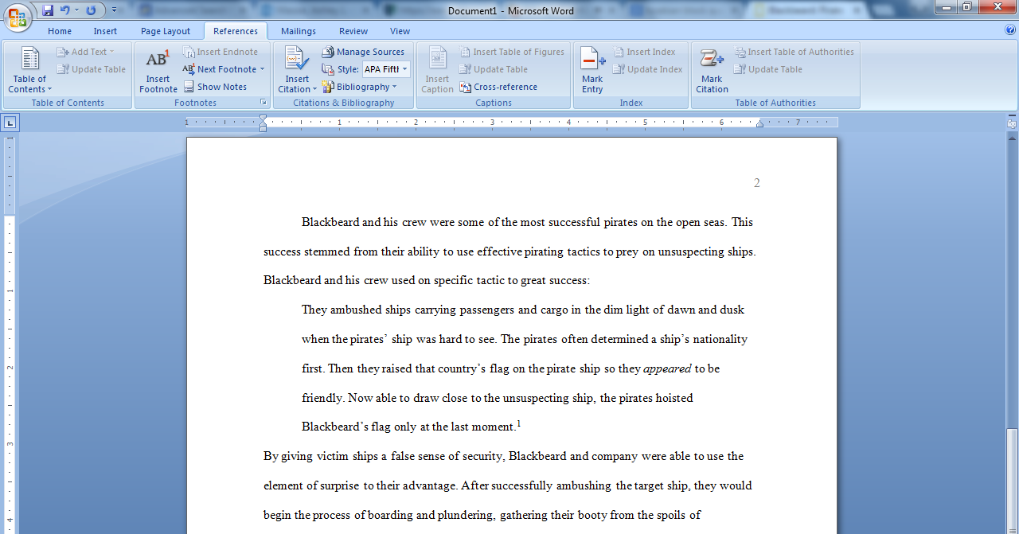

Try not to use too many block quotes in your paper. Your own words should make up the bulk of your paper’s text.

Hanging Indent
Each citation on your Bibliography page should be formatted with a hanging indent. A hanging indent occurs when the first line of the citation begins on the left-hand margin and the second line of the citation is indented half an inch from that margin. To format your Bibliography page using hanging indent, use the following steps:

- Place your cursor at the very end of your paper and press the “Ctrl” and “Enter” keys at the same time to create a page break.
- If Word automatically indents on the new page, press the “Backspace” key once to delete the indent.
- Click on the center button () in the “Paragraph” section of Word’s “Home” menu.
- Type “Bibliography” (without quotation marks) as your title.
- Press the “Enter” key and click on the left justify button () to return your cursor to the left-side margin of your page.
- Type out all of your References page citations, pressing the “Enter” key after each citation.
- Select all of your citations, but do not select page’s title.
- Press the “Ctrl” and “T” keys at the same time to format your hanging indent automatically.
- Your citation(s) should end up looking like the example below.

The citations on your Bibliography page and your footnotes should follow Turabian guidelines. For more information regarding Turabian citations, please consult the Turabian style manual or your professor’s instructions when available.

